SECTION 6 – USER INSTRUCTIONS

Impact Protectors suitable for Use in Motorcycle Clothing
The protector has been certificated by SATRA Technology EuropeLtd,Bracetown Business Park Clonee, Dublin, D15 YN2P, Ireland (2777) in accordance with the European standard EN 1621-1:2012 Motorcyclists’ protective clothing against mechanical impact – part 1: Motorcyclists’ limb protectors – Requirements and test methods,
accordance with the European standard EN 1621-3: 2018 Motorcyclists’ protective clothing against mechanical impact – part 3: Motorcyclists’ Chest protectors – Requirements and test methods.

The EU Declaration of Conformity for this product can be found at:

The protector is designed to provide limited protection against minor injuries caused by impacts with road surfaces as a result of a motorcycle accident.

This product is intended to be worn inside a suitable pocket within an appropriate outer garment.

The inclusion of EU approved impact protectors in a garment does not imply that the whole garment is EU approved.

Product Identification
This user information is applicable to the following products:

CERTI NO :Product Name /Code | Protector Style | Protector Type | Performance Level Achieved |  | Suitable Pocket size  Withmm.  /length mm
8484 HEX S | S | A | 1 |  | 170/200
8484 HEX EK | E/K | A | 1 |  | 165 / 260
8669 HEX LADY S | S | A | 1 |  | 155 / 190
8669 HEX LADY EK | E/K | A | 1 |  | 155 / 250
8731 HEX PRO S | S | B | 2 |  | 175 / 210
8731 HEX PRO EK | E/K | B | 2 |  | 170 / 265
8732 HEX LADY PRO S | S | A | 2 |  | 155/190
8732 HEX LADYPRO EK | E/K | A | 2 |  | 155/250
9131 HEX PRO H | H | A | 2 |  | 180 /220
9132 SLIM EK | EK | A | 1 |  | 155 / 250
9201 NANKAI CHEST DC | DC | A | 1 |  | 180 / 250
9202 HEX PRO LONGKNEE K+L | K+L | B | 2 |  | 170 / 350

Protector Style & Type. The protector style denotes the area the pad covers (S = Shoulder, E = Elbow, K = Knee & upper Tibia , H = Hip & K+L = K = Knee, upper &middle Tibia, DC=Divided chest. ‘Type B’ protectors have larger dimensions and are optimised (although not exclusively) for larger riders ‘Type A’ have smaller dimensions and are optimised (although not exclusively) for smaller riders

Level of protection; EN 1621-1: 2012 / EN 1621-3:2018 has 2 performance levels. Level 2 products offer a higher level of protection than Level 1 products.

- Limb protector

Level 1 | Level 2
Mean value < 35kN | Mean value < 20kN

- Chest protector

IMPACT ATTENUATION | LEVEL 1 and LEVEL 2
Overall mean value | ≤ 18 kN
Single value | ≤ 24 kN

IMPACT DISTRIBUTION | LEVEL 2
Overall mean value | ≤ 15 kN
Single value | ≤ 20 kN

If used correctly, the protectorsthat are detailed within this user information booklet can prevent or reduce the severity of injuries associated with motorcyclists following a road accident.

Warnings!
These protectors cannot guarantee protection against injuries caused by high-energy impacts, twisting, penetration, bending, or crushing, and cannot prevent fatalities.

The tests were carried out, as required by the standard EN 1621-1: 2012, at a temperature of (23±2)°C and at a relative humidity of (50±5)% after pre-conditioning in accordance with the mandatory Ambient &Wetconditioning requirements specified within the standard EN 1621-1: 2012. It is important to recognize the influence of changes in the environmental conditions such as temperature, and that extremes of temperature could significantly reduce the overall performance of these products.

These products do not contain any harmful substances such as allergens or carcinogens that may affect the wearers health.

The retailer and manufacturer will be absolved of all liability in respect of any personal injury or other claims arising from the use of the products other than are intended, including unauthorised user modifications, actions or exposures.

Do not make any alterations, expose to extreme temperatures, petrochemicals, solvents nor their fumes, or treat in any manner that is not the intended use of the protector as this may significantly reduce their level of protection.

The wearer must avoid choosing shoulder protectors that are too big because interference with the helmet may occur resulting in dangerous riding conditions

Instructions for Use
When choosing a protector, choose a protector that is of the correct size and is comfortable when adopting your usual riding position.

The user should always check the right direction when inserting the protector into the pocket inside the clothing. This product should not be worn separately or be worn in direct contact with your skin or clothing.

When positioned correctly the “upper” side of the protector shall be the one that has the bigger radius which covers the joint and runs in the direction of the length of the limb. The protector shall not be turned by 90° or 180° as this will no longer provide the wearer with adequate protective coverage.

This product should be positioned correctly inside a suitable pocket within the outer garment.

Use with additional personal protective equipment
To achieve the maximum available levels of protection in the event of an accident, these limb protectors should be used in conjunction with compatible, correctly fitting items of PPE which give coverage to areas of the body not protected by the limb protectors alone. In addition to a safety helmet, a total PPE package of products type-approved and CE marked against the requirements of European Standards for motorcyclists’ protective clothing should be used, comprising, boots, gloves and jacket & trousers or one-piece/two-piece suit.

Marking
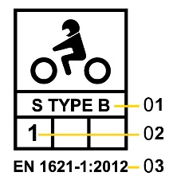
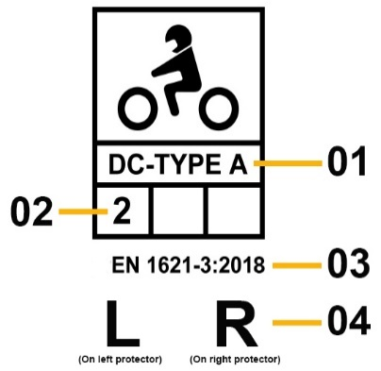
1. Protector style&type(S= shoulder. E=Elbow, EK= Elbow/Knee, K=Knee
K+L = Knee,upper& middle Tibia, H=Hip, C= Chest , DC = Divided Chest
A= type A, B= type B)
2. Performance Level
3. Standard protector meets
4. Left or Right
5. Read the instruction before use
Key
1 Protective equipment for motorcycle riders (ISO7000-2618)
2 Category and type of the protector
3 Low temperature impact test passed (if the space is vacant, the test is not claimed)
4 High temperature impact test passed (if the space is vacant, the test is not claimed)
5 Performance Level

The CE Mark is to be interpreted as follows:

European Conformity mark = CE Mark
Manufacturer Name / Trade mark and address =SHINIL SPORTS INC(POWERTECTOR)
Product code = HEX S/HEX EK/HEX LADY S/ HEX LADY EK/HEX PRO S/HEX PRO EK/HEX LADY PRO S/HEX LADY PRO EK/HEX PRO H / HEX PRO LONGKNEE K+L /SLIM EK / NANKAI CHEST
Protector Style = S / E / K / H / K + L /DC (Shoulder, Elbow, Knee, Hip, Knee + Leg, DIVIDED CHEST))
Protector Type =TYPE A / TYPE B
Standard Number = EN 1621-1: 2012 / EN 1621-3:2018
Performance Level Achieved During Assessment = Level 1 / Level 2
T+ = High temperature impact test passed (if the space is vacant, the test is not claimed)
T- = Low temperature impact test passed (if the space is vacant, the test is not claimed)
Postal Address

Zone of Protection
The protection is offered within the central shaded area of the protector as shown on the diagrams provided below.

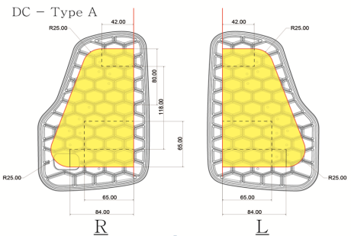

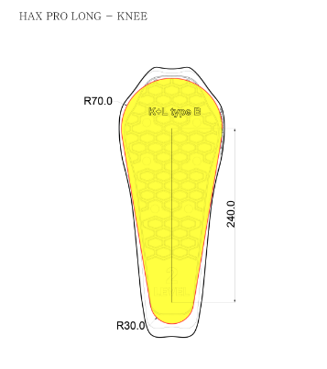
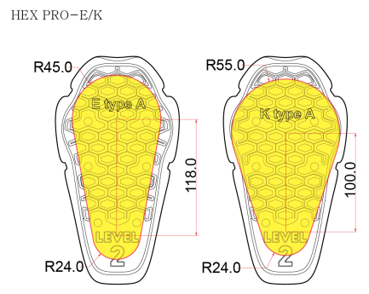
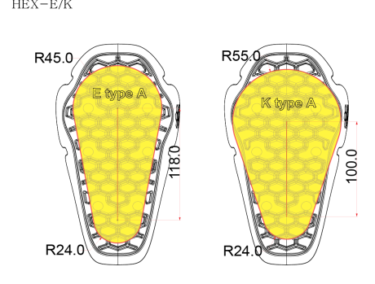
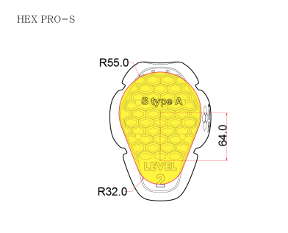
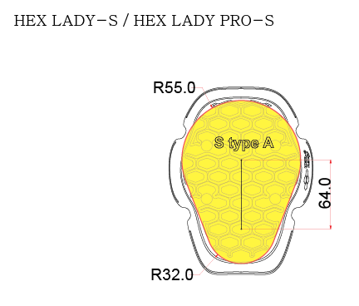
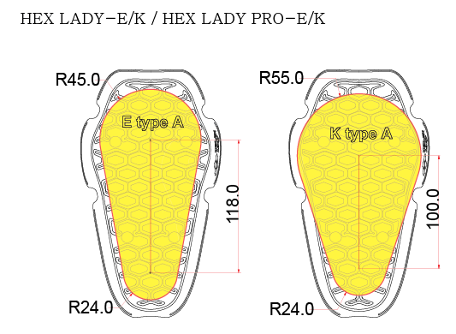
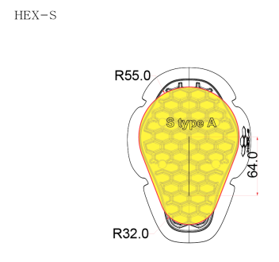

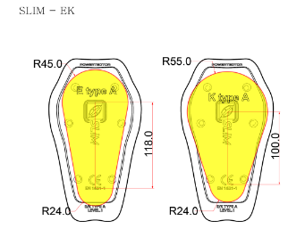
+
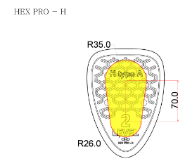

Maintenance
It is very important to check your impact protectors regularly for any signs of damage which may reduce the level of protection being offered by the protector. If the protectors show any sign of wear, surface damage, or reduced thickness and density of the protector, replace the product immediately.
As the impact protector cannot be repaired following any impact, the limb protectors should be replaced immediately, as any resulting damagemay reduce the effectiveness of the protector.

Dependant upon the regularity and severity of use, your limb protectors should have a minimum service life of2 years, although this may vary and products should be visually inspected prior to each use for damage or other irregularities as outlined above.

Used products should be disposed of in accordance with the local / national environmental regulations at an appropriate land fill site. Further information regarding these regulations can be obtained from your local authorities.

Repairs / Modifications
The manufacturer cannot guarantee the performance of the product or the level of protection that is offered by the protector if modifications or repairs are carried out on this product by the user.

Storage
The protector should be stored in a dry, ventilated environment away from direct sunlight, heat sources, and sharp objects.

Do not place beneath heavy items that may damage the protector.

Do not expose the protectors to chemical substances, hazardous substances, or fire, which may contaminate the product and have an adverse effect on the level of protection offered by these products.

Cleaning

To avoid any damage the protectors should be removed from clothing before washing or cleaning.
If soiled, wipe gently with a soft cloth damped in cool water.
Do not use detergents or solvent cleaners.
Allow to air dry away from sunlight or direct heat sources before refitting to your garment.

Note: This product does not contain any harmful substances such as allergens or carcinogens that may effect the wearers health

These motorcyclists’ protectors are manufactured and distributed by:

SHINIL SPORTS INC. (POWERTECTOR)
2917, Cheongno-ro, Gangnam-myeon, Pocheon-si, Gyeonggi-do,
11155, South Korea

